**NAME : PRATHAPANI SATWIKA**

**REG.NO. : 20BCD7160**

**EXPERIMENT NO. 2**

**Objective : To Verify the Ohm’s Law**

**Software used : NI Multisim**

**Theory :**

**Ohm's law** states that **“**at a constant temperature, the electrical current flowing through a conductor is directly proportional to the voltage applied across it, and also inversely proportional to the resistance **”** .

Mathematically can be written as :

**V ∝ I ;**

**I = V/R**

**V = IR**

**Where ,**

**V =** Voltage measured across the

conductor

**R =** Resistance of the conductor

**I =** Current through the conductor

**CIRCUIT DIAGRAM :**

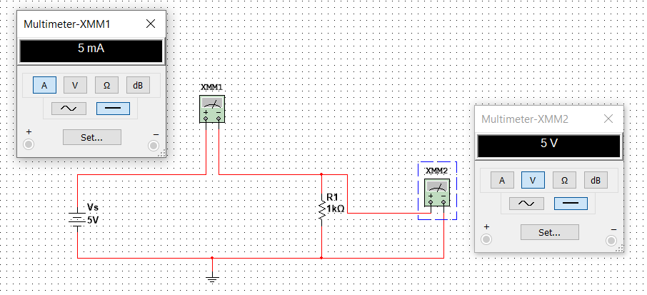

**RESULTS AND OBSERVATIONS :**

**THEORITICAL MUTISIM**

|  |  |  |  |  |  |  |
| --- | --- | --- | --- | --- | --- | --- |
| **S.NO.** | **Vs** | **R(ohm)** | **I** | **Vout** | **I** | **Vout** |
| **1.** | 5V | 1K | 5mA | 5V | 5mA | 5V |
| **2.** | 8V | 3K | 2.667mA | 8.001V | 2.667mA | 8V |
| **3.** | 12V | 8K | 1.5mA | 12V | 1.5mA | 12V |
| **4.** | 16V | 9K | 1.778mA | 16.002V | 1.778mA | 16V |
| **5.** | 18V | 12K | 1.5mA | 18V | 1.5mA | 18V |

**EXPERIMENT NO.4**

**Objective :** To verify the Voltage and Current

division Principle .

**Software used :** NI Multisim

**Theory :**

**Voltage division rule** states that **“**The voltage across any resistor in a series connection of resistors is equal to the ratio of the value of the resistor divided by the total resistance of the circuit **”** .

**Vout = (Vs * R1) / (R1 + R2)**

**Vout = (Vs * R2) / (R1 + R2)**

**Current division rule** states that **“**The current in any parallel branches of the circuit is equal to the ratio of opposite branch resistance to total resistance , multiplied by total current . The current division rule determines the current across the circuit impedance **” .**

**I1 = (Is * R1) / (R1 + R2)**

**I2 = (Is * R2) / (R1 + R2)**

**Circuit Diagram :**

**Voltage division principle :**

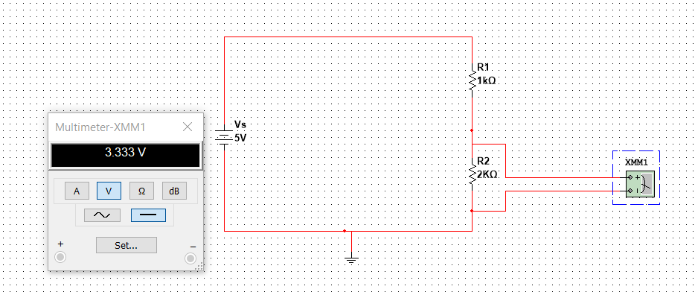

**Circuit – 1**

**Current division principle :**

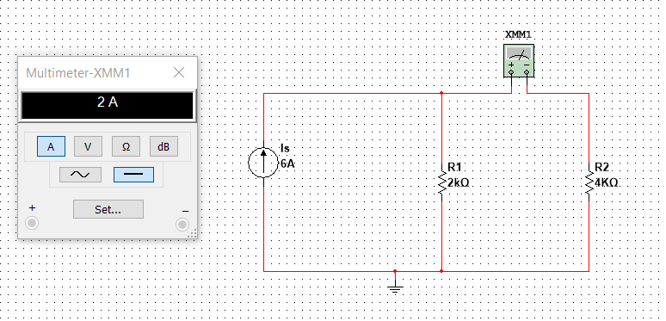

**Circuit - 2**

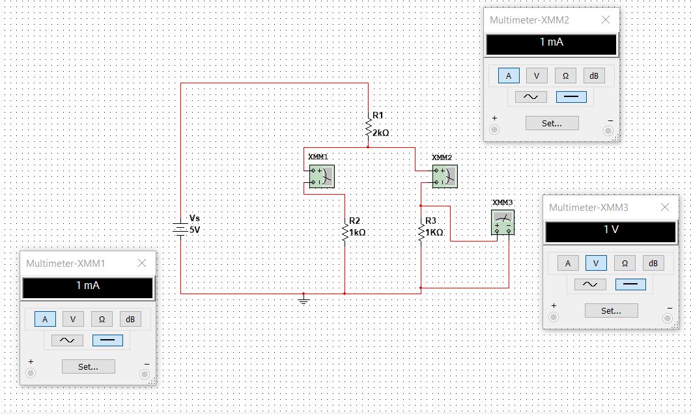

**Circuit – 3**

**RESULTS AND OBSERVATIONS :**

**For Voltage division principle :**

**Circuit – 1 :**

|  |  |  |  |  |  |
| --- | --- | --- | --- | --- | --- |
| **S.NO.** | **Vs(volt)** | **R1(ohm)** | **R2(ohm)** | **THEORITICAL**  **Vout** | **MULTISIM**  **Vout** |
| **1.** | 5 | 1K | 2K | 3.333V | 3.333V |
| **2.** | 5 | 2K | 3K | 3V | 3V |
| **3.** | 5 | 2.5K | 3.1K | 2.767V | 2.768V |
| **4.** | 5 | 4K | 3.2K | 2.222V | 2.222V |
| **5.** | 10 | 6K | 4.5K | 4.285V | 4.286V |

**For Current division Principle :**

**Circuit – 2 :**

|  |  |  |  |  |  |
| --- | --- | --- | --- | --- | --- |
| **S.NO.** | **Is(Ampere)** | **R1(ohm)** | **R2(ohm)** | **THEORITICAL**  **Iout** | **MULTISIM**  **Iout** |
| **1.** | 6 | 2k | 4k | 2A | 2A |
| **2.** | 3 | 2K | 4K | 1A | 1A |
| **3.** | 5 | 1.2K | 2.5K | 1.621A | 1.622A |
| **4.** | 8 | 1.6K | 1.4K | 4.266A | 4.267A |
| **5.** | 6 | 1.8K | 1.6K | 3.176A | 3.176A |

**Circuit – 3 :**

|  |  |  |  |  |  |  |  |
| --- | --- | --- | --- | --- | --- | --- | --- |
| **Multisim values** | | | | | | | |
| **S.NO.** | **Vs** | **R1(ohm)** | **R2(ohm)** | **R3(ohm)** | **I1** | **I2** | **Vout** |
| **1.** | 5V | 2K | 1K | 1K | 1mA | 1mA | 1V |
| **2.** | 6V | 1K | 2K | 2K | 1.5mA | 1.5mA | 3V |
| **3.** | 8V | 2K | 2K | 1K | 2mA | 1mA | 2V |